**Quick Start--Icloud**

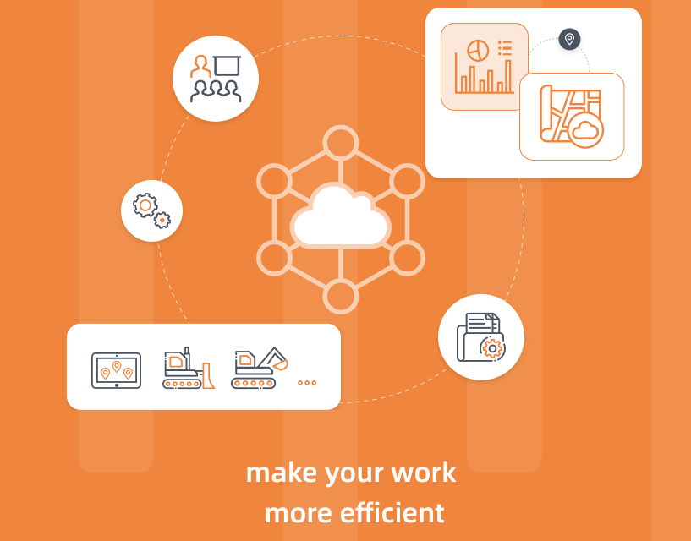



Table of Contents

1. Web links for icloud 2

2. Log in 2

3. Create a new account 4

4. Add a machine from cloud 9

5. Add a machine from terminal 10

6. Cloud project sync 11

**June 22, 2025**

# Web links for icloud

For Europe:https://mc-eu.chcnav.com

For Russia:https://mc-ru.chcnav.com

For China:https://mc.huace..com

# Log in

If you already have an account, log in with the following method

if you don't have an account yet, refer to Section 3 [Create a new account]

* Password login

Enter your email address and password, enter the verification code, and click the Login button

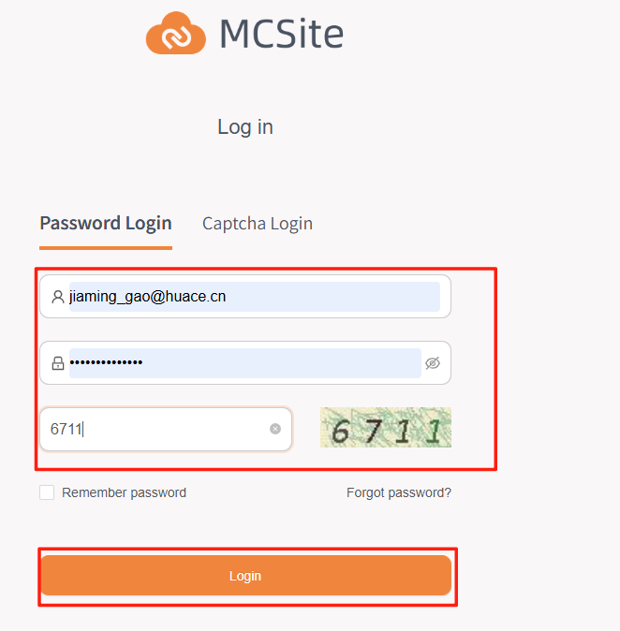

* Captcha login

Enter your email address and click the [Get code] button, and a verification code will be sent to your email address,input it then click on [log in]

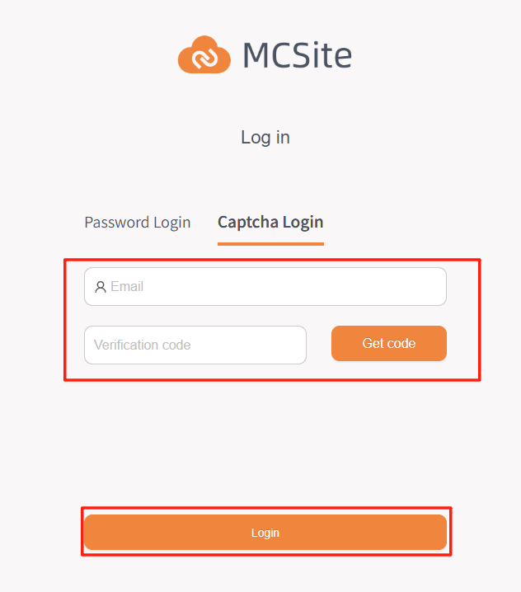

# Create a new account

* For dealer

1. Send the email address you used to log in to the cloud platform to the machine control technician and an invitation will be sent to your e-mail



1. Open the link, log in, and create a password for your account,enter the verification code you received from your email address and click [Registration] button

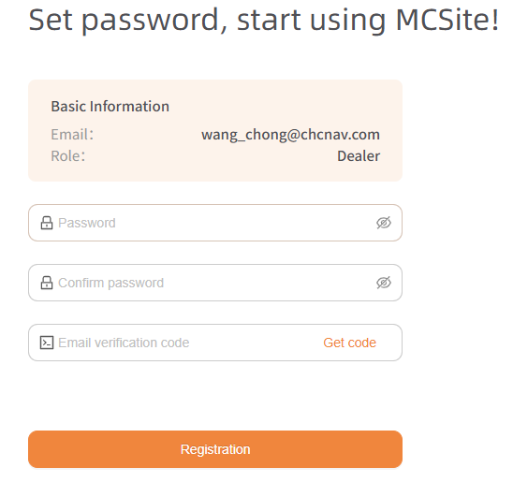

* For surveyor

This menu is used for dealers to create accounts for their subordinates (surveyors, project site workers, etc.),before this, the dealer needs to complete the account registration , only in this way the surveyor's account and the dealer have a binding relationship, and can assign work to surveyor

1. Send an invitation to the surveyor(Operated by dealer)
2. Create company information for different roles

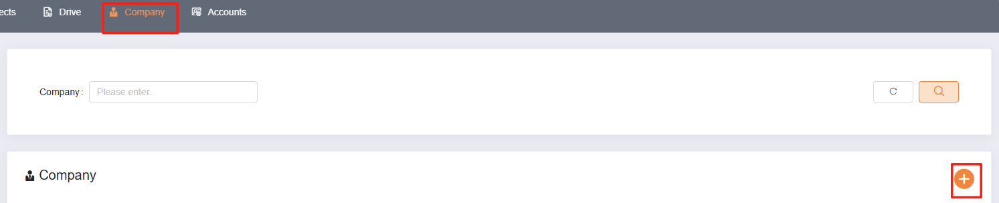

Enter the company information on the next page

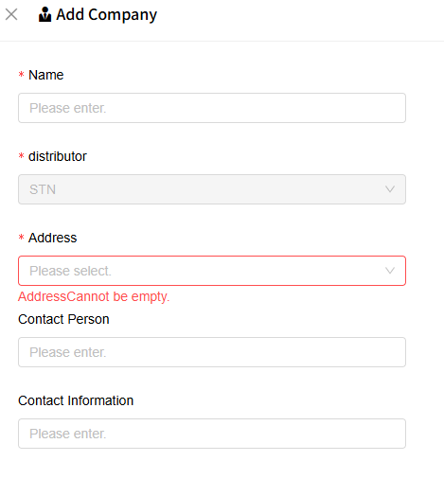

Note: If you think the address need not be very specific, double-click on the country to skip the option to select a city/county

2.Create a role for surveyor or compay management

On the home page of the cloud platform, click [Accounts] - [User Management]

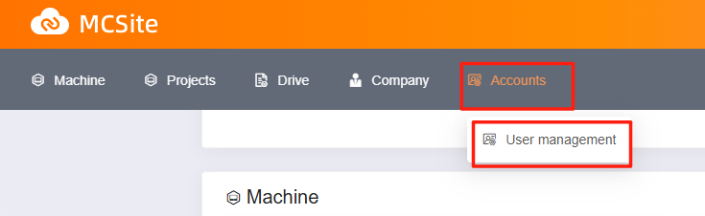

Then click [Add]

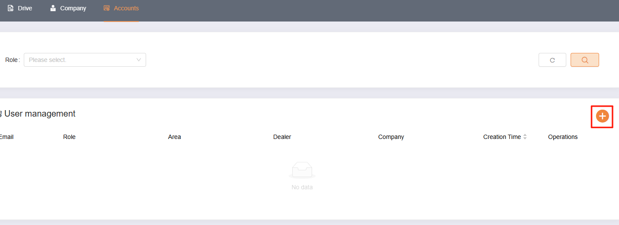

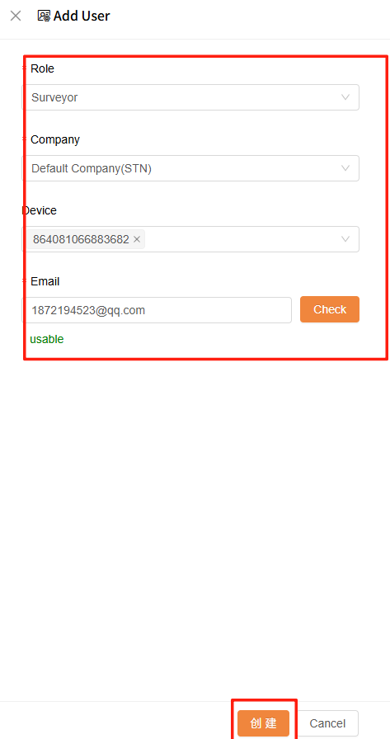

Note:Device is not totally required at this time,If you select a device at this time, the device will be automatically bound when the surveyor completes the registration

The surveyor's email will receive an invitation

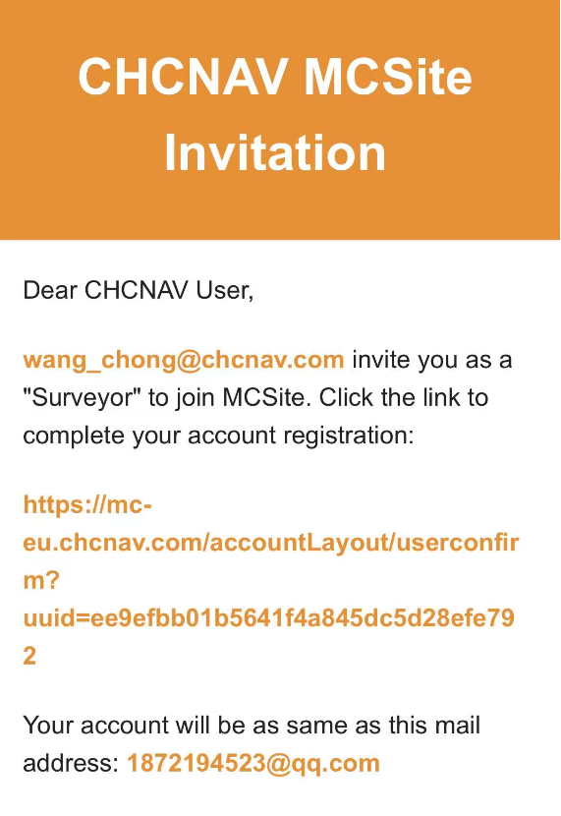

1. Register and log in

It is exactly the same as the dealer registration login interface

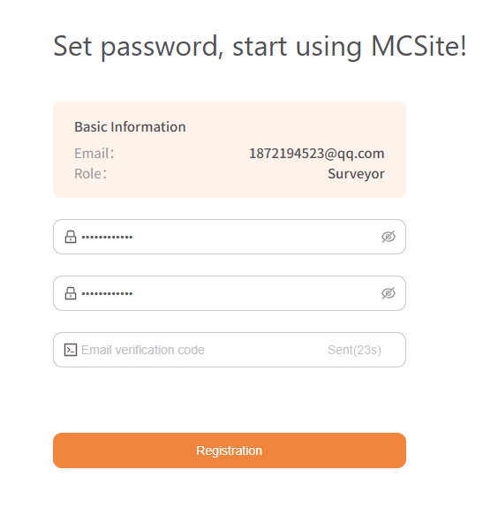

# Add a machine from cloud

* Add a new machine

Click on [Machine]-[Add machinery] button,input corresponding information

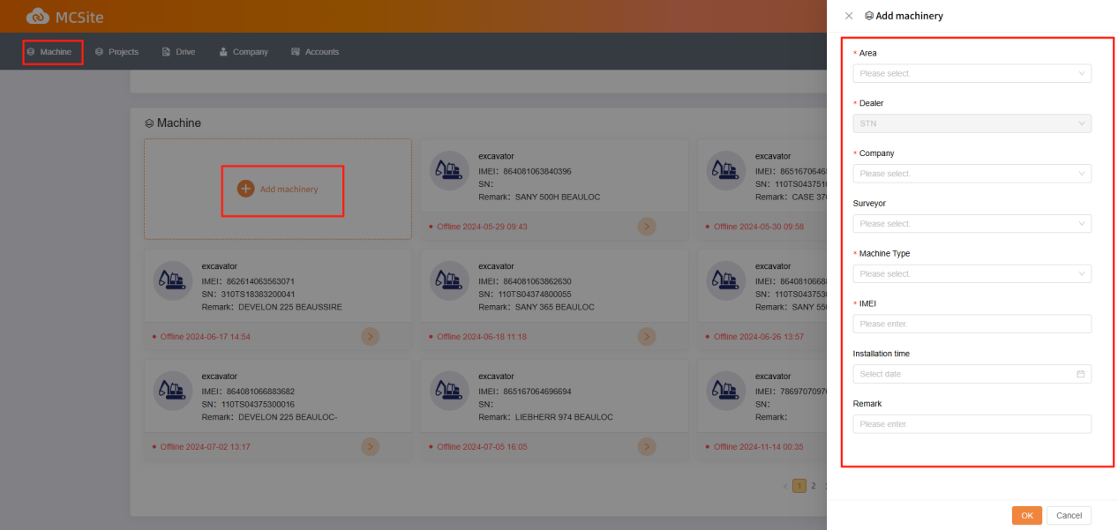

Note:If a surveyor is selected at this time, the device will automatically appear in the surveyor's device list

* Bind a previous machine for surveyor

Click [Accounts]-[Users management],Find the surveyor's account and click [Edit button

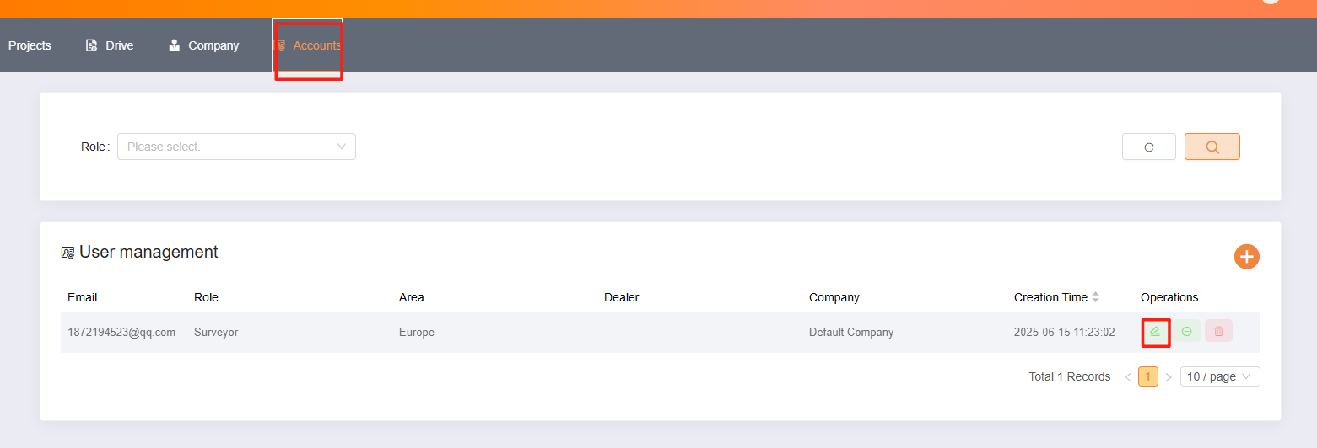

Select the machine you want to add from the equipment list

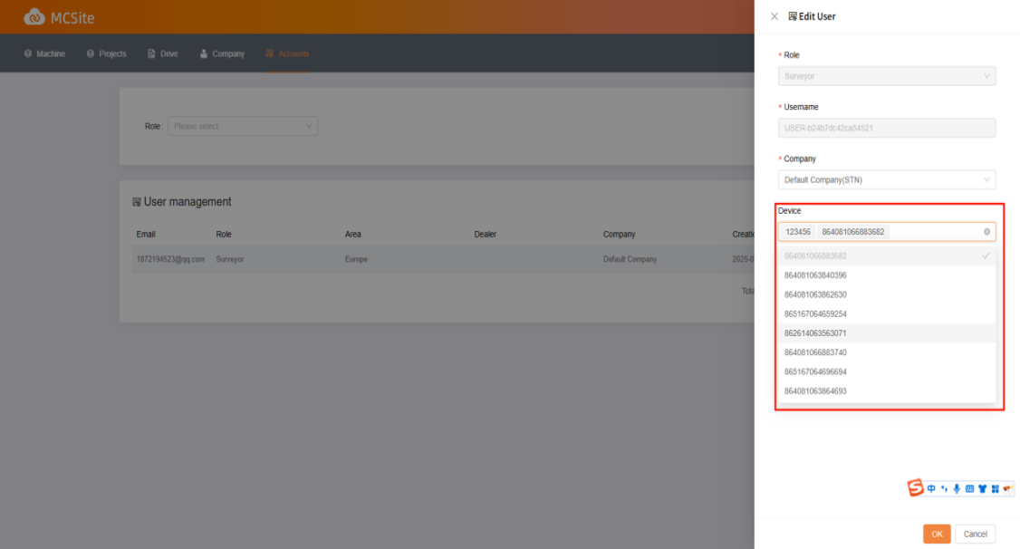

# Add a machine from terminal

5.1 Click on [menu]-[language and region]-[Bind]

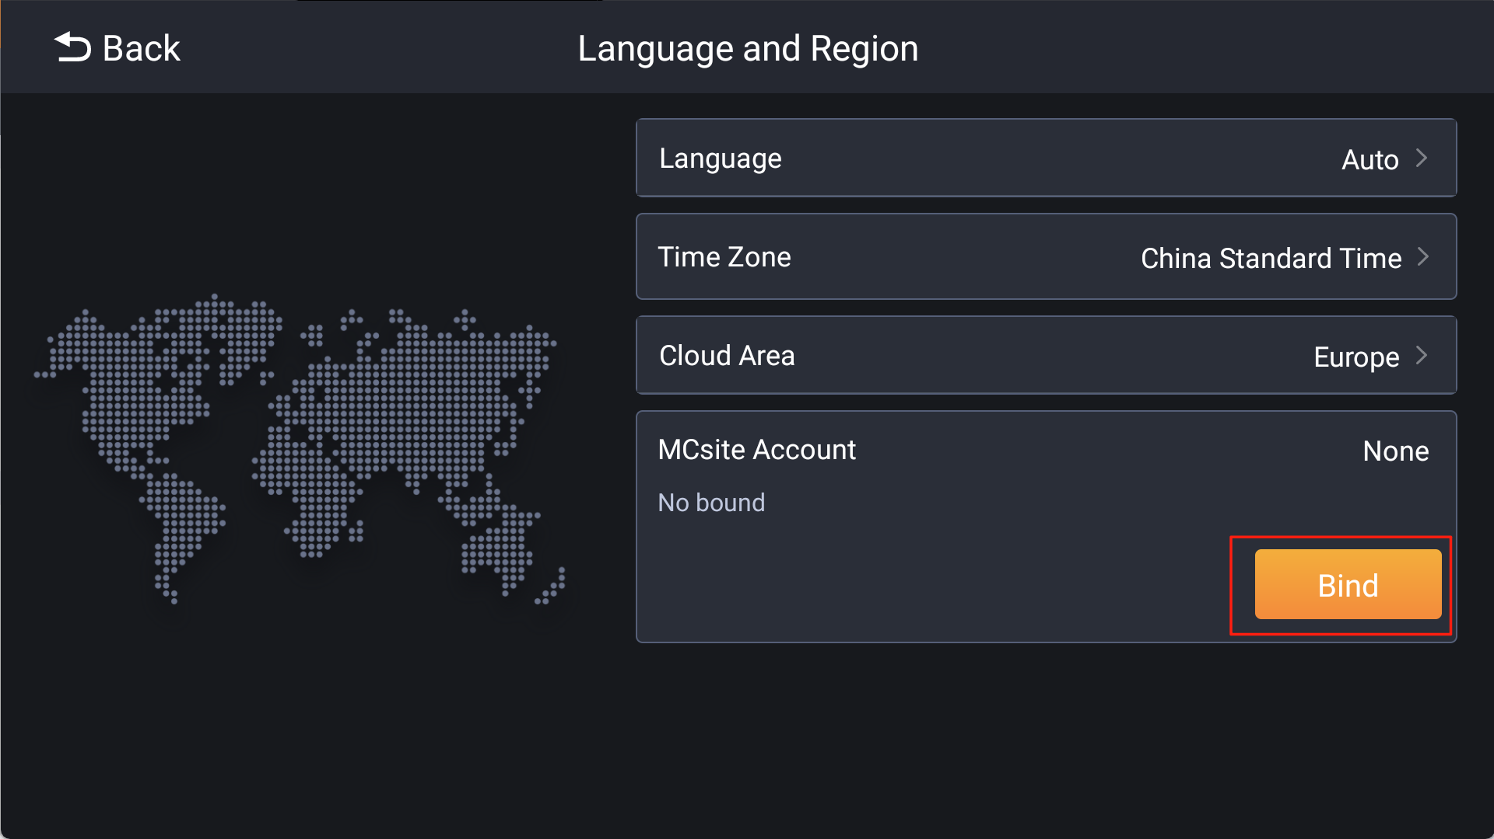

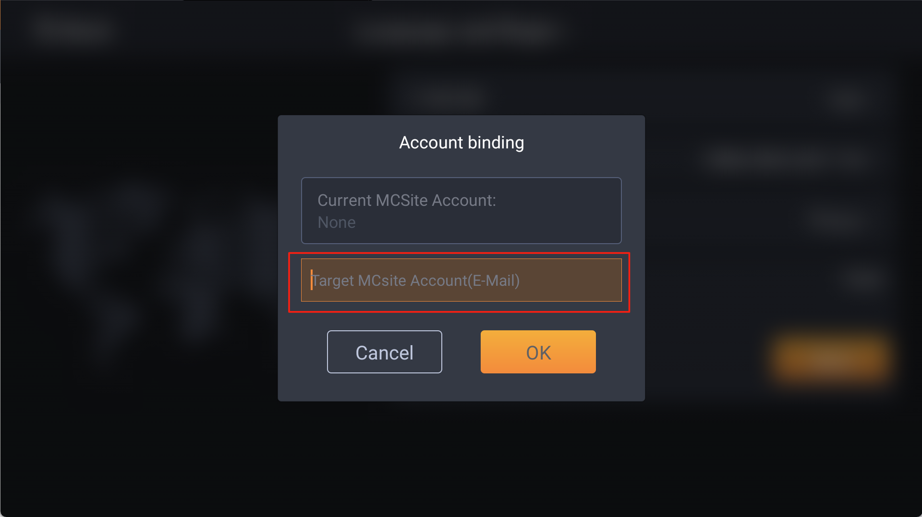

5.2 The target email will receive a binding request, click the link in the email to confirm.

# Cloud project sync

6.1 Create a cloud project

Click on [Project]-[Add]

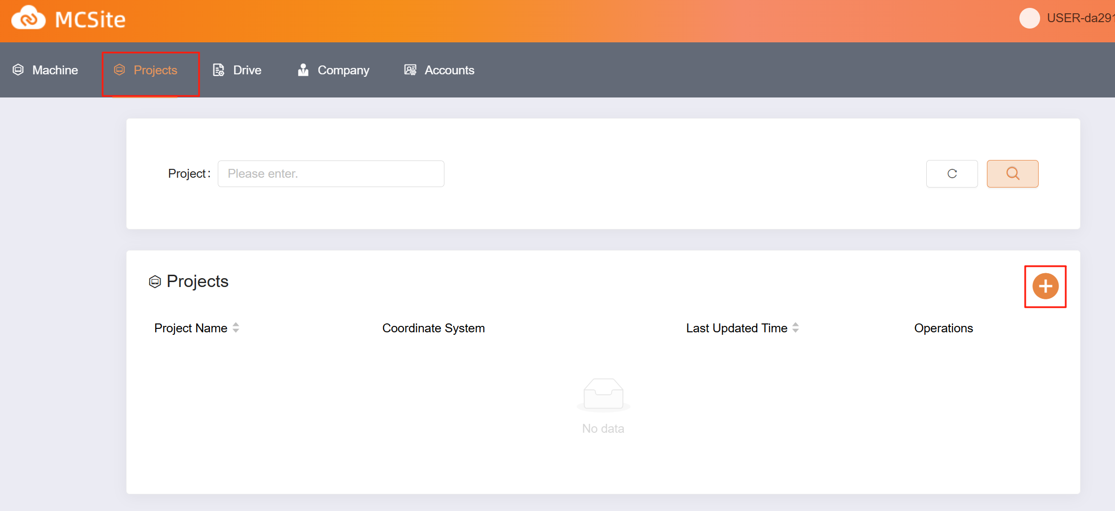

Coorperation modes are divided into public and private:  
Public: All of the company's sub-users and upper-level users can view the project  
Private: Only the person who created the project can view the project

You can select a preset coordinate grid or upload a custom format

6.2 Upload the design file

Click the name of the target project,Choose [Local Upload] or[Library Upload]

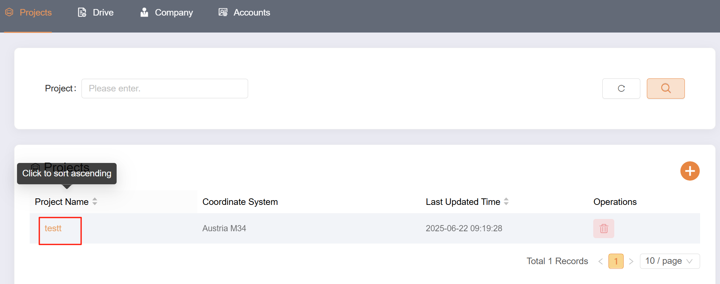

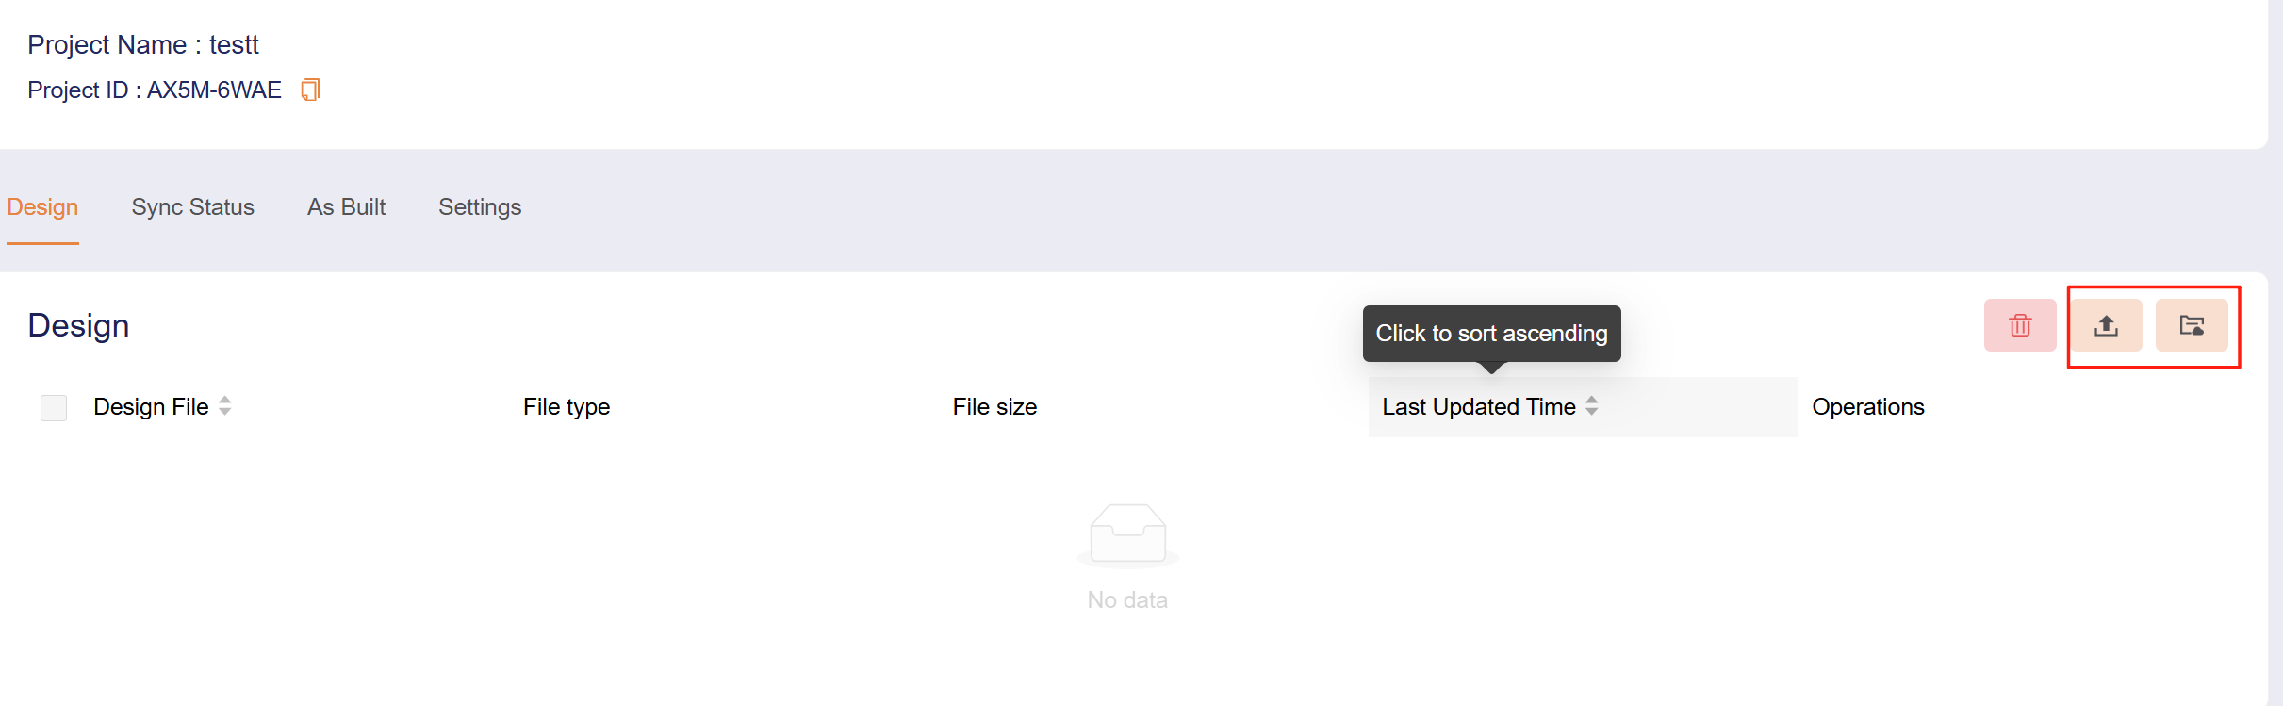

6.3 Machine bound cloud projects

In TX73 software,click [menu]-[projects]-[more]-[link to],Enter the target project ID,which display by clicking the project name on cloud web

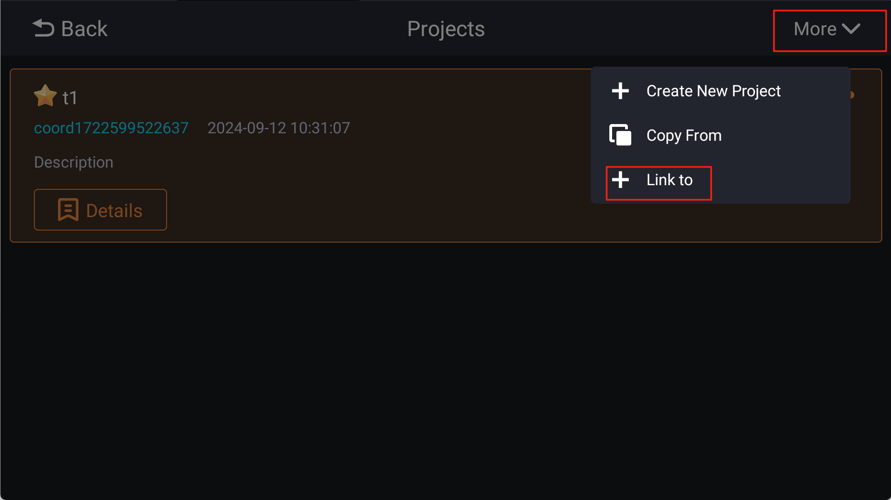

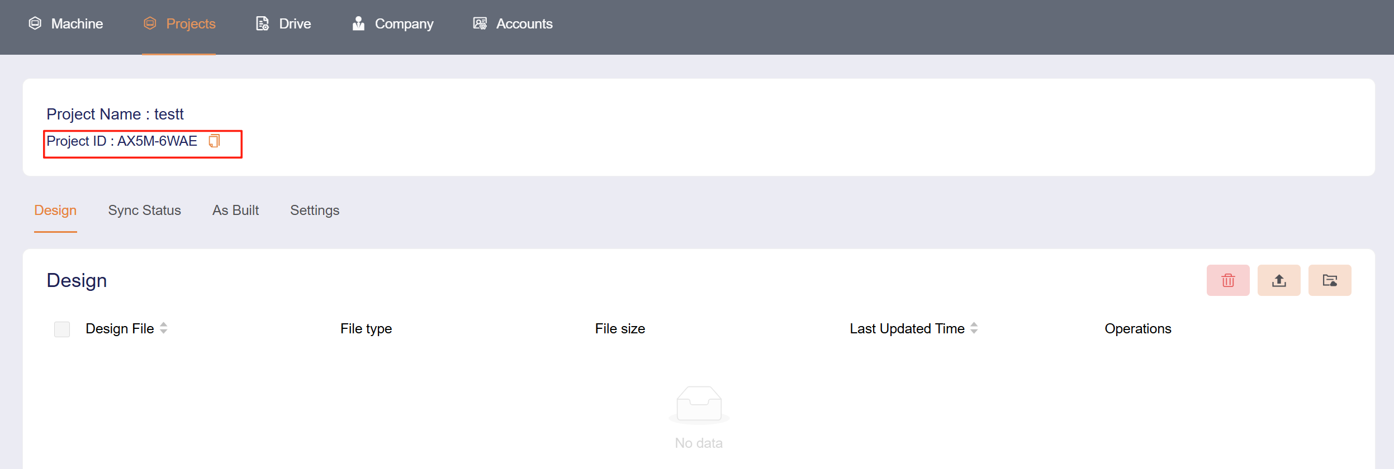

The machine can be viewed in the synchronization state, and the operation is supported: disconnect the link with the device, retry sync, and cancel sync

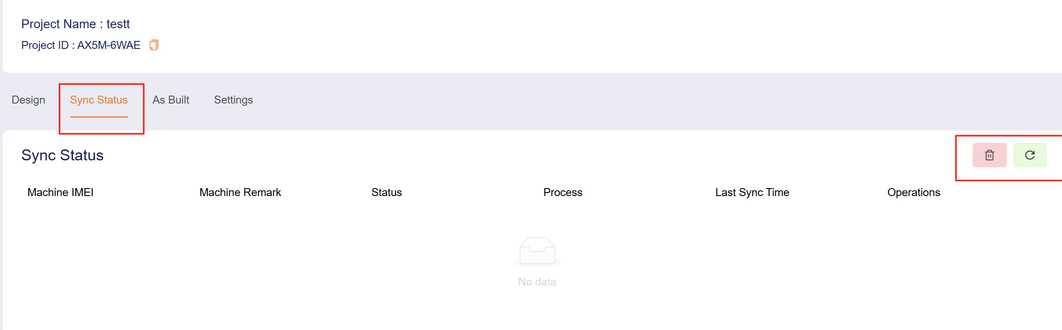

Machine will make the sync uploading after manually clicking retry sync and last modify of design date with 30 mins

6.4 Upload as-built data

Upload the as-built data to cloud ,operated on the machine

In as-built interface ,you can delete and export

